10.36: For both parts, 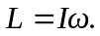 Also, 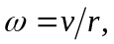 so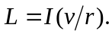

a) 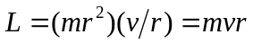
b) 